Contents

Overview/Introduction 2

Statement of Problem 2

Objective 3

Literature Review 3

Methodology 3

Working Schedule 5

Expected Results 6

References 6

## Overview/Introduction

we propose an automated attendance management system. This system, which is based on face detection and recognition algorithms, automatically detects the student and marks the attendance by recognizing them. The system architecture and algorithms used in each stage are described in this proposal. The "Face recognition attendance system" is a hardware prototype of a face recognition attendance system. This project is developed using Raspberry pi, RPI camera, Convolutional Neural Network and Python coding. Face recognition is an important application of Image processing owing to its use in many fields. Identification of individuals in an organization for the purpose of attendance is one such application of face recognition. Maintenance and monitoring of attendance records plays a vital role in the analysis of performance of any organization. The purpose of developing attendance management system is to computerize the traditional way of taking attendance. Automated Attendance Management System performs the daily activities of attendance marking and analysis with reduced human intervention. The prevalent techniques and methodologies for detecting and recognizing face fail to overcome issues such as scaling, pose, illumination, variations, rotation, and occlusions. The proposed system aims to overcome the pitfalls of the existing systems and provides features such as detection of faces, extraction of the features, detection of extracted features, and analysis of students' attendance. The technique behind the face recognition the training images are feed into the model and model learn the parameters. After learning parameters, the sliding window technique is used to classify the images and detect the faces in the real time. The system is tested for various use cases. We consider a specific area such as classroom attendance for the purpose of testing the accuracy of the system

## Statement of Problem

In this modern era of automation many scientiﬁc advancements and inventions have taken place to save labor, increase the accuracy and to ameliorate our lives. The traditional attendance systems in school and colleges have been so time consuming, old fashioned and no so efficient to keep track of the students. Automated Attendance System is the advancement that has taken place in the ﬁeld of automation replacing traditional attendance marking activity. Automated Attendance Systems are generally biometric based, smart-card based and web based. These systems are widely used in diﬀerent organizations. Traditional method of attendance marking is very time consuming and becomes complicated when the strength is more. Automation of Attendance System has edge over traditional method as it saves time and also can be used for security purposes. This also helps to prevent fake attendance. An Attendance Management System which is developed using biometrics, in our case face, generally consists of Image Acquisition, Database development, Face detection, Preprocessing, Feature extraction, and Classiﬁcation stages followed by Post-processing stage

## 

## Objective

The objectives of the project are given below:

1. Detection of unique face image amidst the other natural components such as walls, backgrounds etc.

2. Extraction of unique characteristic features of a face useful for face recognition.

3. Effective recognition of unique faces in a crowd (individual recognition in crowd).

4. Automated update in the database without human intervention.

## Literature Review

In [1] the authors have proposed a ﬁnger print based attendance system. A portable ﬁngerprint device has been developed which can be passed among the students to place their ﬁnger on the sensor during the lecture time without the instructor’s intervention. This system guarantees a fool-proof method for marking the attendance. The problem with this approach is that passing of the device during the lecture time may distract the attention of the students. A number of works related to Radio Frequency Identiﬁcation (RFID) based Attendance Systems exist in the literature. In [2] the authors have proposed RFID based system in which students carry a RFID tag type ID card and they need to place that on the card reader to record their attendance. RS232 is used to connect the system to the computer and save the recorded attendance from the database. This system may give rise to the problem of fraudulent access. An unauthorized person may make use of authorized ID card and enter into the organization. Iris is the another biometric that can be used for Attendance Systems. In [3] the authors have proposed Daugman’s algorithm based Iris recognition system. This system uses iris recognition management system that does capturing the image of iris recognition, extraction, storing and matching. But the diﬃculty occurs to lay the transmission lines in the places where the topography is bad. In [4] authors have proposed a system based on real time face recognition which is reliable, secure and fast which needs improvement in diﬀerent lighting conditions.

## Methodology

In this proposed system, the system is instantiated automatically after the classes starts. After it triggers then the system starts processing the image for which we want to mark the attendance. Image capturing phase is one in which we capture the image using Raspberry pi and raspi camera. This is basic phase from which we start initializing our system. First the image is capture after that sliding window technique is used and save the bunch of images in jpg format. From the saved image folder each and every images are feed into the model that is built in Convolutional Neural Network architecture. In which first feature is extracted using convolutional and pooling layer after that the 3-layer depth image is flatten into two dimension. The flatten images is the feed into the multiple layer neural network and uses the softmax function to classify the feed image. According to the label of images the stored name of student is extracted from database and update the database as per the classified images.

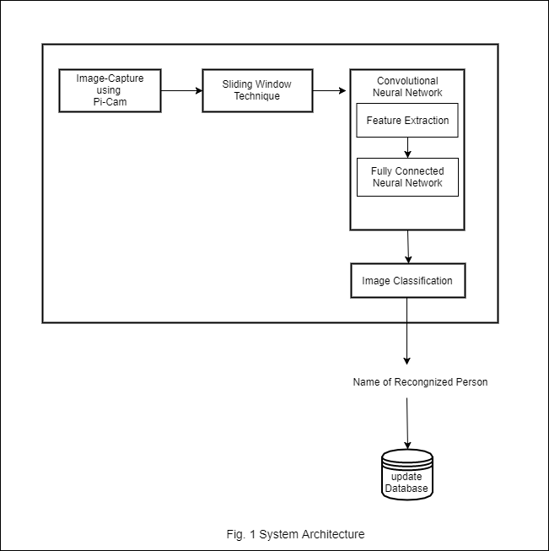

**Algorithm Used:**

1. Convolutional Neural Network

**Convolutional Neural Network:**

**Description:**

A CNN consists of a number of convolutional and subsampling layers optionally followed by fully connected layers. The input to a convolutional layer is a ‘m x m x r’ image where m is the height and width of the image and r is the number of channels, e.g. an RGB image has ‘r=3’. The convolutional layer will have k filters (or kernels) of size ‘n x n x q’ where n is smaller than the dimension of the image and q can either be the same as the number of channels ‘r’ or smaller and may vary for each kernel. The size of the filters gives rise to the locally connected structure which are each convolved with the image to produce kk feature maps of size ‘m−n+1’. Each map is then subsampled typically with mean or max pooling over ‘p x p’ contiguous regions where p ranges between 2 for small images (e.g. MNIST) and is usually not more than 5 for larger inputs. Either before or after the subsampling layer an additive bias and sigmoidal nonlinearity is applied to each feature map. The figure below illustrates a full layer in a CNN consisting of convolutional and subsampling sublayers. Units of the same color have tied weights.

**Pros:**

The main motivation behind the emergence of CNNs in deep learning scenarios has been to address many of the limitations that traditional neural networks faced when applied to those problems. When used in areas like image classification, traditional fully-connected neural networks simply don’t scale well due to their disproportionally large number of connections. CNNs bring a few new ideas that contribute to improve the efficiency of deep neural networks.

**Cons:**

1. High computational cost.
2. If you don't have a good GPU they are quite slow to train (for complex tasks).
3. They use to need a lot of training data.

## Working Schedule

|  |  |  |  |  |
| --- | --- | --- | --- | --- |
| Activities/Duration | April-May | May-June | June-July | July-August |
| Data Collection |  |  |  |  |
| Design |  |  |  |  |
| Development |  |  |  |  |
| Implementation |  |  |  |  |

## Expected Results

## References

[1] B. K. Mohamed and C. Raghu, “Fingerprint attendance system for classroom needs,” in India Conference (INDICON), 2012 Annual IEEE. IEEE, 2012, pp. 433–438.

[2] T. Lim, S. Sim, and M. Mansor, “Rﬁd based attendance system,” in Industrial Electronics & Applications, 2009. ISIEA 2009. IEEE Symposium on, vol. 2. IEEE, 2009, pp. 778–782.

[3] S. Kadry and K. Smaili, “A design and implementation of a wireless iris recognition attendance management system,” Information Technology and control, vol. 36, no. 3, pp. 323–329, 2007

[4] T. A. P. K. K. L. P. M. L. M. P. A. W. G. D. P. J. G.. RoshanTharanga, S. M. S. C. Samarakoon, “Smart attendance using real time face recognition,” 2013.